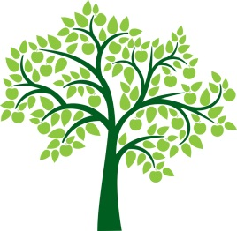
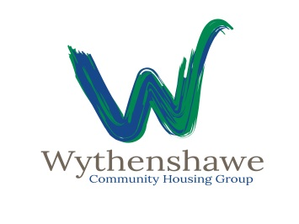

Withy Tree Youth Bank

Who Can apply?
You can apply for this funding if your project benefits young people between the ages of 10-19, and reside within the M22/ M23 postcode.

What type of youth activities will we support?
Sports & Health
Enterprise
Arts
Life skills

What type of activity will we not consider funding for?
We will not fund anything that is linked with Religious groups or illegal activity, or one off trips.

What is the maximum amount you can apply for?
The minimum amount you can apply for is £250; the maximum amount is £1500. You can ask for part or full funding for your project.

What else will help me with my funding bid?
Some of the key points we will be judging are:
- Value for money.
- Creativity.
- Impact on the community.

How will I know if my bid has been successful or not?
You will be asked to attend and deliver your pitch (Which you can include YP you work with) for your project idea; this will be held as a young person’s event. At the event Young people will decide which projects will be funded through a voting system.

How will you capture expenditure and accountability for money, and outcomes for your project?
We would expect there to be financial accountability in the form of a spreadsheet and receipts. We will deliver a mid-point inspection to ensure you are meeting your outcomes as stipulated in your project plan.

Closing date for applications:

31st August

Notice of Shortlisting by:

14th September

Date for pitching your idea:

17th October

Funding release date:

28th October

Please return completed applications to youthinvolvement@wchg.org.uk

